- Implement and demonstrate the FIND-S algorithm for finding the most specific hypothesis based on a given set of training data samples.
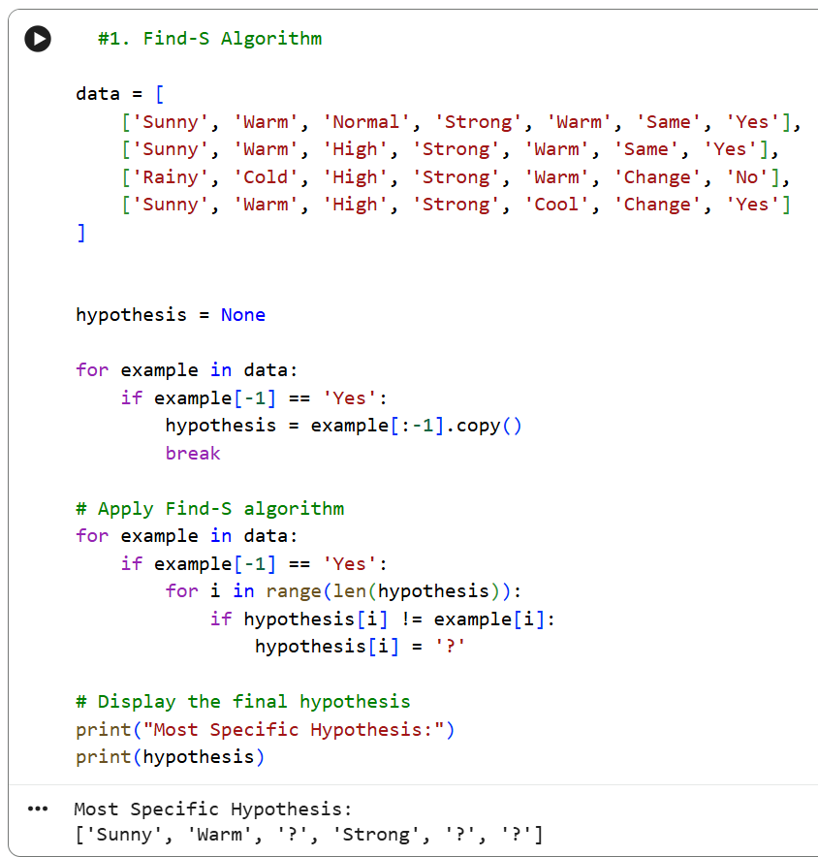

output:

Most Specific Hypothesis:
['Sunny', 'Warm', '?', 'Strong', '?', '?']

- For a given set of training data examples stored in a .CSV file, implement and demonstrate the Candidate-Elimination algorithm in python to output a description of the set of all hypotheses consistent with the training examples

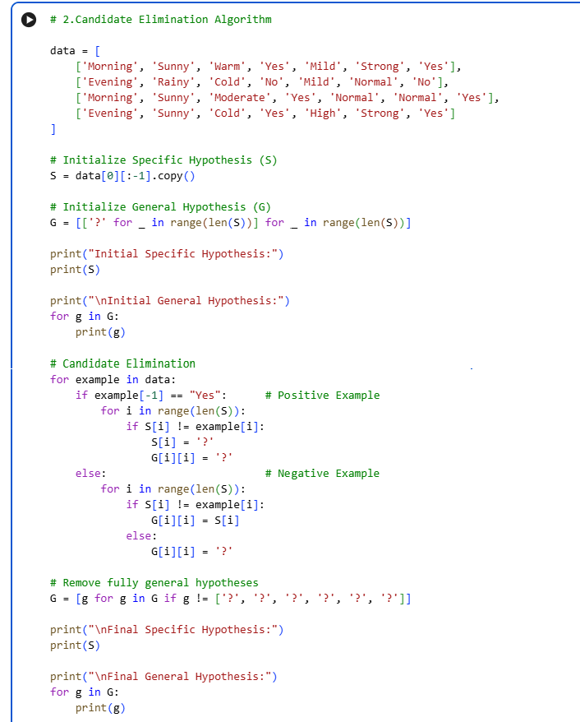

Output :

Initial Specific Hypothesis:
['Morning', 'Sunny', 'Warm', 'Yes', 'Mild', 'Strong']

Initial General Hypothesis:
['?', '?', '?', '?', '?', '?']
['?', '?', '?', '?', '?', '?']
['?', '?', '?', '?', '?', '?']
['?', '?', '?', '?', '?', '?']
['?', '?', '?', '?', '?', '?']
['?', '?', '?', '?', '?', '?']

Final Specific Hypothesis:
['?', 'Sunny', '?', 'Yes', '?', '?']

Final General Hypothesis:
['?', 'Sunny', '?', '?', '?', '?']
['?', '?', '?', 'Yes', '?', '?']

- Demonstrate the working of the decision tree based ID3 algorithm. Use an appropriate data set for building the decision tree and apply this knowledge to classify a new sample.

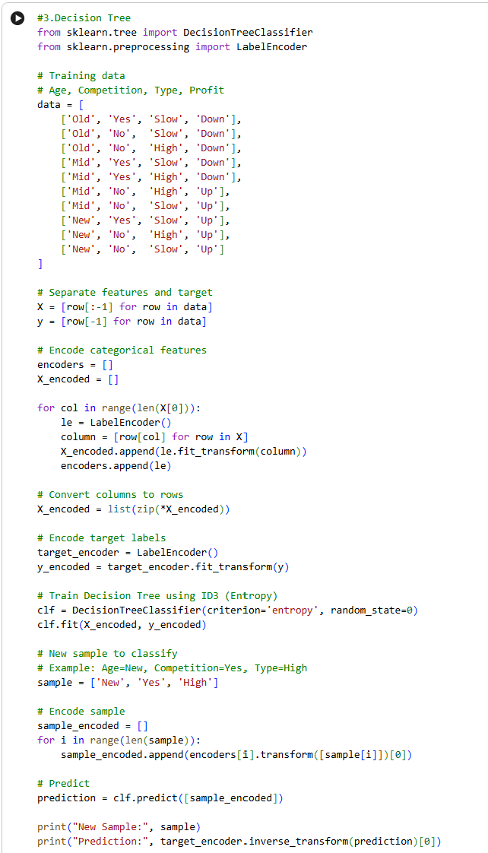

Output:
New Sample: ['New', 'Yes', 'High']
Prediction: Up

4.Build an Artificial Neural Network by implementing the Backpropagation algorithm and test the same using appropriate data sets.
#4 ARTIFICIAL NEURAL NETWORK USING BACKPROPAGATION
import numpy as np

class NeuralNetwork:

def __init__(self, input_size, hidden_size=4):
np.random.seed(42)

# Initialize weights
self.W1 = np.random.randn(input_size, hidden_size)
self.b1 = np.zeros((1, hidden_size))

self.W2 = np.random.randn(hidden_size, 1)
self.b2 = np.zeros((1, 1))

# Sigmoid Activation Function
def sigmoid(self, x):
return 1 / (1 + np.exp(-x))

# Derivative of Sigmoid
def sigmoid_derivative(self, x):
return x * (1 - x)

# Forward Propagation
def forward(self, X):

self.hidden_input = np.dot(X, self.W1) + self.b1
self.hidden_output = self.sigmoid(self.hidden_input)

self.final_input = np.dot(self.hidden_output, self.W2) + self.b2
self.output = self.sigmoid(self.final_input)

return self.output

# Backpropagation
def backward(self, X, y, learning_rate):

# Output error
output_error = y - self.output

output_delta = (
output_error *
self.sigmoid_derivative(self.output)
)

# Hidden layer error
hidden_error = np.dot(
output_delta,
self.W2.T
)

hidden_delta = (
hidden_error *
self.sigmoid_derivative(self.hidden_output)
)

# Update weights
self.W2 += learning_rate * np.dot(
self.hidden_output.T,
output_delta
)

self.b2 += learning_rate * np.sum(
output_delta,
axis=0,
keepdims=True
)

self.W1 += learning_rate * np.dot(
X.T,
hidden_delta
)

self.b1 += learning_rate * np.sum(
hidden_delta,
axis=0,
keepdims=True
)

# Train Network
def train(self, X, y, epochs=5000, learning_rate=0.1):

for epoch in range(epochs):

self.forward(X)

self.backward(
X,
y,
learning_rate
)

# Prediction
def predict(self, X):

output = self.forward(X)

return (output >= 0.5).astype(int)

# =========================================================
# FUNCTION TO TEST DATASET
# =========================================================

def test_dataset(name, X, y):

print("\n====================================")
print(name)
print("====================================")

X = np.array(X, dtype=float)
y = np.array(y, dtype=float).reshape(-1, 1)

# Normalize inputs
X = X / np.max(X, axis=0)

# Create Neural Network
model = NeuralNetwork(
input_size=X.shape[1]
)

# Train
model.train(
X,
y,
epochs=5000,
learning_rate=0.1
)

# Prediction
predictions = model.predict(X)

print("Actual Output:")
print(y.flatten())

print("Predicted Output:")
print(predictions.flatten())

# Accuracy
accuracy = np.mean(
predictions.flatten() == y.flatten()
) * 100

print("Accuracy:", accuracy, "%")

# =========================================================
# DATASET 1 : STUDENT PASS / FAIL
# Inputs = Study Hours, Attendance
# Output = 0 Fail, 1 Pass
# =========================================================

X1 = [
[2, 50],
[3, 60],
[5, 75],
[6, 85],
[8, 95]
]

y1 = [
0,
0,
1,
1,
1
]

test_dataset(
"DATASET 1 - STUDENT PASS/FAIL",
X1,
y1
)

# =========================================================
# DATASET 2 : LOAN APPROVAL
# Inputs = Income, Credit Score
# Output = 0 Rejected, 1 Approved
# =========================================================

X2 = [
[20000, 400],
[30000, 500],
[45000, 650],
[60000, 720],
[80000, 800]
]

y2 = [
0,
0,
1,
1,
1
]

test_dataset(
"DATASET 2 - LOAN APPROVAL",
X2,
y2
)

# =========================================================
# DATASET 3 : EMPLOYEE PROMOTION
# Inputs = Experience, Performance Score
# Output = 0 Not Promoted, 1 Promoted
# =========================================================

X3 = [
[1, 40],
[2, 50],
[4, 70],
[6, 85],
[8, 95]
]

y3 = [
0,
0,
1,
1,
1
]

test_dataset(
"DATASET 3 - EMPLOYEE PROMOTION",
X3,
y3
)

# =========================================================
# DATASET 4 : DISEASE RISK
# Inputs = Age, Blood Pressure
# Output = 0 Low Risk, 1 High Risk
# =========================================================

X4 = [
[20, 110],
[30, 115],
[45, 140],
[55, 150],
[65, 170]
]

y4 = [
0,
0,
1,
1,
1
]

test_dataset(
"DATASET 4 - DISEASE RISK",
X4,
y4
)

# =========================================================
# DATASET 5 : PRODUCT PURCHASE
# Inputs = Age, Salary
# Output = 0 Not Purchased, 1 Purchased
# =========================================================

X5 = [
[18, 15000],
[22, 20000],
[30, 40000],
[40, 60000],
[50, 80000]
]

y5 = [
0,
0,
1,
1,
1
]

test_dataset(
"DATASET 5 - PRODUCT PURCHASE",
X5,
y5
)

Output :

====================================
DATASET 1 - STUDENT PASS/FAIL
====================================
Actual Output:
[0. 0. 1. 1. 1.]
Predicted Output:
[0 0 1 1 1]
Accuracy: 100.0 %

====================================
DATASET 2 - LOAN APPROVAL
====================================
Actual Output:
[0. 0. 1. 1. 1.]
Predicted Output:
[0 0 1 1 1]
Accuracy: 100.0 %

====================================
DATASET 3 - EMPLOYEE PROMOTION
====================================
Actual Output:
[0. 0. 1. 1. 1.]
Predicted Output:
[0 0 1 1 1]
Accuracy: 100.0 %

====================================
DATASET 4 - DISEASE RISK
====================================
Actual Output:
[0. 0. 1. 1. 1.]
Predicted Output:
[0 0 1 1 1]
Accuracy: 100.0 %

====================================
DATASET 5 - PRODUCT PURCHASE
====================================
Actual Output:
[0. 0. 1. 1. 1.]
Predicted Output:
[0 0 1 1 1]
Accuracy: 100.0 %

5.Write a program for Implementation of K-Nearest Neighbours (K-NN) in Python
#5. Implementation of K-Nearest Neighbours (K-NN)

import numpy as np
from collections import Counter

# ============================================================
# K-NEAREST NEIGHBOURS (K-NN) FROM SCRATCH
# ============================================================

class KNN:
def __init__(self, k=3):
self.k = k

# Store training data
def fit(self, X, y):
self.X_train = np.array(X, dtype=float)
self.y_train = np.array(y)

# Euclidean Distance
def euclidean_distance(self, x1, x2):
return np.sqrt(np.sum((x1 - x2) ** 2))

# Predict one sample
def predict_one(self, x):

distances = []

for i in range(len(self.X_train)):
distance = self.euclidean_distance(
x,
self.X_train[i]
)

distances.append(
(distance, self.y_train[i])
)

# Sort according to distance
distances.sort(key=lambda x: x[0])

# Select K nearest neighbours
nearest = distances[:self.k]

# Get their classes
labels = [label for distance, label in nearest]

# Majority voting
prediction = Counter(labels).most_common(1)[0][0]

return prediction

# Predict multiple samples
def predict(self, X):
X = np.array(X, dtype=float)

predictions = []

for x in X:
predictions.append(self.predict_one(x))

return predictions

# ============================================================
# FUNCTION TO TEST EACH DATASET
# ============================================================

def test_dataset(name, X, y, test_data, k=3):

print("\n========================================")
print(name)
print("========================================")

model = KNN(k=k)

# Train
model.fit(X, y)

# Predict
predictions = model.predict(test_data)

print("Test Data:")
print(np.array(test_data))

print("\nPredicted Class:")
print(predictions)

# ============================================================
# DATASET 1 : STUDENT RESULT
# Features:
# Study Hours, Attendance
#
# 0 = Fail
# 1 = Pass
# ============================================================

X1 = [
[1, 40],
[2, 50],
[3, 55],
[5, 75],
[6, 80],
[7, 90],
[8, 95]
]

y1 = [
0, 0, 0,
1, 1, 1, 1
]

test1 = [
[4, 70]
]

test_dataset(
"DATASET 1 - STUDENT RESULT",
X1,
y1,
test1
)

# ============================================================
# DATASET 2 : LOAN APPROVAL
# Features:
# Income, Credit Score
#
# 0 = Rejected
# 1 = Approved
# ============================================================

X2 = [
[20000, 400],
[25000, 450],
[30000, 500],
[45000, 650],
[55000, 700],
[65000, 750],
[80000, 800]
]

y2 = [
0, 0, 0,
1, 1, 1, 1
]

test2 = [
[50000, 680]
]

test_dataset(
"DATASET 2 - LOAN APPROVAL",
X2,
y2,
test2
)

# ============================================================
# DATASET 3 : EMPLOYEE PROMOTION
# Features:
# Experience, Performance Score
#
# 0 = Not Promoted
# 1 = Promoted
# ============================================================

X3 = [
[1, 40],
[2, 45],
[3, 55],
[4, 70],
[5, 75],
[6, 85],
[8, 95]
]

y3 = [
0, 0, 0,
1, 1, 1, 1
]

test3 = [
[5, 80]
]

test_dataset(
"DATASET 3 - EMPLOYEE PROMOTION",
X3,
y3,
test3
)

# ============================================================
# DATASET 4 : PRODUCT PURCHASE
# Features:
# Age, Salary
#
# 0 = Not Purchased
# 1 = Purchased
# ============================================================

X4 = [
[18, 15000],
[22, 20000],
[25, 25000],
[30, 40000],
[35, 50000],
[40, 60000],
[50, 80000]
]

y4 = [
0, 0, 0,
1, 1, 1, 1
]

test4 = [
[32, 45000]
]

test_dataset(
"DATASET 4 - PRODUCT PURCHASE",
X4,
y4,
test4
)

# ============================================================
# DATASET 5 : CUSTOMER SUBSCRIPTION
# Features:
# Age, Monthly Spending
#
# 0 = Not Subscribed
# 1 = Subscribed
# ============================================================

X5 = [
[20, 1000],
[22, 1500],
[25, 2000],
[30, 3500],
[35, 4500],
[40, 5500],
[45, 6500]
]

y5 = [
0, 0, 0,
1, 1, 1, 1
]

test5 = [
[33, 4000]
]

test_dataset(
"DATASET 5 - CUSTOMER SUBSCRIPTION",
X5,
y5,
test5
)
Output:

========================================
DATASET 1 - STUDENT RESULT
========================================
Test Data:
[[ 4 70]]

Predicted Class:
[np.int64(1)]

========================================
DATASET 2 - LOAN APPROVAL
========================================
Test Data:
[[50000 680]]

Predicted Class:
[np.int64(1)]

========================================
DATASET 3 - EMPLOYEE PROMOTION
========================================
Test Data:
[[ 5 80]]

Predicted Class:
[np.int64(1)]

========================================
DATASET 4 - PRODUCT PURCHASE
========================================
Test Data:
[[ 32 45000]]

Predicted Class:
[np.int64(1)]

========================================
DATASET 5 - CUSTOMER SUBSCRIPTION
========================================
Test Data:
[[ 33 4000]]

Predicted Class:
[np.int64(1)]

6.Write a program to implement Naïve Bayes algorithm in python and to display the results using confusion matrix and accuracy.
#6. Implementation of Naive Bayes Algorithm

import numpy as np
from sklearn.naive_bayes import GaussianNB
from sklearn.metrics import confusion_matrix, accuracy_score

def test_naive_bayes(name, X_train, y_train, X_test, y_test):

print("\n========================================")
print(name)
print("========================================")

# Create Naive Bayes Model
model = GaussianNB()

# Train the model
model.fit(X_train, y_train)

# Predict test data
y_pred = model.predict(X_test)

print("Actual Output:")
print(y_test)

print("Predicted Output:")
print(y_pred)

# Confusion Matrix
cm = confusion_matrix(y_test, y_pred)

print("\nConfusion Matrix:")
print(cm)

# Accuracy
accuracy = accuracy_score(y_test, y_pred)

print("\nAccuracy:", accuracy * 100, "%")

# ============================================================
# DATASET 1 : STUDENT PASS / FAIL
# Features = Study Hours, Attendance
# 0 = Fail
# 1 = Pass
# ============================================================

X1_train = np.array([
[1, 40],
[2, 45],
[2, 50],
[3, 55],
[4, 60],
[5, 70],
[6, 75],
[7, 80],
[8, 90],
[9, 95]
])

y1_train = np.array([
0, 0, 0, 0, 0,
1, 1, 1, 1, 1
])

X1_test = np.array([
[2, 48],
[3, 52],
[6, 72],
[7, 85]
])

y1_test = np.array([
0, 0, 1, 1
])

test_naive_bayes(
"DATASET 1 - STUDENT PASS/FAIL",
X1_train,
y1_train,
X1_test,
y1_test
)

# ============================================================
# DATASET 2 : LOAN APPROVAL
# Features = Income, Credit Score
# 0 = Rejected
# 1 = Approved
# ============================================================

X2_train = np.array([
[20000, 400],
[25000, 450],
[28000, 480],
[30000, 500],
[35000, 550],
[45000, 650],
[50000, 680],
[60000, 720],
[70000, 760],
[80000, 800]
])

y2_train = np.array([
0, 0, 0, 0, 0,
1, 1, 1, 1, 1
])

X2_test = np.array([
[26000, 460],
[32000, 520],
[55000, 700],
[75000, 780]
])

y2_test = np.array([
0, 0, 1, 1
])

test_naive_bayes(
"DATASET 2 - LOAN APPROVAL",
X2_train,
y2_train,
X2_test,
y2_test
)

# ============================================================
# DATASET 3 : EMPLOYEE PROMOTION
# Features = Experience, Performance Score
# 0 = Not Promoted
# 1 = Promoted
# ============================================================

X3_train = np.array([
[1, 40],
[1, 45],
[2, 48],
[2, 50],
[3, 55],
[4, 70],
[5, 75],
[6, 80],
[7, 88],
[8, 95]
])

y3_train = np.array([
0, 0, 0, 0, 0,
1, 1, 1, 1, 1
])

X3_test = np.array([
[2, 46],
[3, 52],
[5, 78],
[7, 90]
])

y3_test = np.array([
0, 0, 1, 1
])

test_naive_bayes(
"DATASET 3 - EMPLOYEE PROMOTION",
X3_train,
y3_train,
X3_test,
y3_test
)

# ============================================================
# DATASET 4 : PRODUCT PURCHASE
# Features = Age, Salary
# 0 = Not Purchased
# 1 = Purchased
# ============================================================

X4_train = np.array([
[18, 15000],
[20, 18000],
[22, 20000],
[24, 23000],
[26, 26000],
[30, 40000],
[35, 50000],
[40, 60000],
[45, 70000],
[50, 80000]
])

y4_train = np.array([
0, 0, 0, 0, 0,
1, 1, 1, 1, 1
])

X4_test = np.array([
[21, 19000],
[25, 24000],
[32, 45000],
[48, 75000]
])

y4_test = np.array([
0, 0, 1, 1
])

test_naive_bayes(
"DATASET 4 - PRODUCT PURCHASE",
X4_train,
y4_train,
X4_test,
y4_test
)

# ============================================================
# DATASET 5 : CUSTOMER SUBSCRIPTION
# Features = Age, Monthly Spending
# 0 = Not Subscribed
# 1 = Subscribed
# ============================================================

X5_train = np.array([
[18, 1000],
[20, 1200],
[22, 1500],
[24, 1800],
[26, 2200],
[30, 3500],
[35, 4500],
[40, 5500],
[45, 6500],
[50, 7500]
])

y5_train = np.array([
0, 0, 0, 0, 0,
1, 1, 1, 1, 1
])

X5_test = np.array([
[21, 1400],
[25, 2000],
[33, 4000],
[47, 7000]
])

y5_test = np.array([
0, 0, 1, 1
])

test_naive_bayes(
"DATASET 5 - CUSTOMER SUBSCRIPTION",
X5_train,
y5_train,
X5_test,
y5_test
)
Output:

========================================
DATASET 1 - STUDENT PASS/FAIL
========================================
Actual Output:
[0 0 1 1]
Predicted Output:
[0 0 1 1]

Confusion Matrix:
[[2 0]
[0 2]]

Accuracy: 100.0 %

========================================
DATASET 2 - LOAN APPROVAL
========================================
Actual Output:
[0 0 1 1]
Predicted Output:
[0 0 1 1]

Confusion Matrix:
[[2 0]
[0 2]]

Accuracy: 100.0 %

========================================
DATASET 3 - EMPLOYEE PROMOTION
========================================
Actual Output:
[0 0 1 1]
Predicted Output:
[0 0 1 1]

Confusion Matrix:
[[2 0]
[0 2]]

Accuracy: 100.0 %

========================================
DATASET 4 - PRODUCT PURCHASE
========================================
Actual Output:
[0 0 1 1]
Predicted Output:
[0 0 1 1]

Confusion Matrix:
[[2 0]
[0 2]]

Accuracy: 100.0 %

========================================
DATASET 5 - CUSTOMER SUBSCRIPTION
========================================
Actual Output:
[0 0 1 1]
Predicted Output:
[0 0 1 1]

Confusion Matrix:
[[2 0]
[0 2]]

Accuracy: 100.0 %

